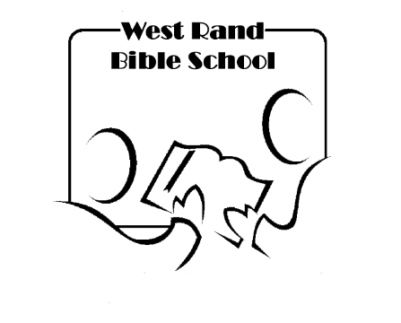**Registration Form**

Understanding Cults

& Heresies

**16 January – 27 March 2024**

**Thursday mornings 9:00 – 11:30 or Online Recordings**

**The New Harvest Christian Fellowship**

|  |  |  |  |  |  |  |
| --- | --- | --- | --- | --- | --- | --- |
| TITLE |  | SURNAME | |  | | |
| FIRST NAMES |  | | | | | |
| PHONE NUMBER |  | | | | | |
| E-MAIL |  | | | | | |
| PLEASE TICK THE RELEVANT OPTION | IN-PERSON | |  | | ONLINE CORRESPONDENCE |  |

**_ _ _ _ _ _ _ _ _ _ _ _ _ _ _ _ _ _ _ _ _ _ _ _ _ _ _ _ _ _ _ _ _ _ _ _ _ _ _ _ _ _ _ _ _ _ _ _**

This course will give an overview of the main cults and heresies that we see in the world today. We will examine the question “What is a cult?” as well as consider what beliefs and practices set a cult or heresy apart from orthodox Christian doctrine.

The course will include an examination of Christian Science/Scientology, Mormonism, Catholicism with its points of difference with Protestantism, 7th Day Adventism, Islam, Freemasonry and Jehovah’s Witnesses.

**Cost: R450 for the term** (includes workbook)

Payments are to be made to:  
**The New Harvest Christian Fellowship  
Bank: FNB  
Branch Number: 251141  
Account Number: 6201 9337 270  
Reference: WRBS (Your Name)**

**Please e-mail your registration form and proof of payment to** [**graham@thenew**](mailto:graham@thenew)**harvest.org.za**